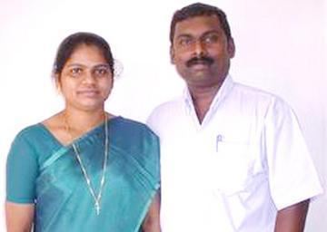
YEARLY REPORT FOR 2016
Happy New Year 2017 to you and your family.
We trust that you are doing well and enjoying the life in its full. We praise God for you and remember you in our prayers. Thank you for your prayer support for us and our nation, India.
We are so excited as God has added one more year into our life to do more for His Kingdom than the year 2016.
The year 2016 was a tremendous year for us. We have experienced the power of God in our personal life and also in the ministry. Gospel of God was preached in different ways to many people. Seeing many non-believers are being set free from the bondage of satan and sin in 2016, encouraged us to preach the Gospel to the unreached people more vigorously in 2017 also. God is so good! Amen!
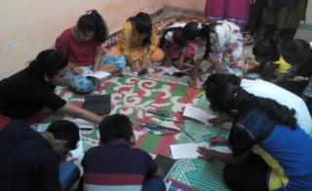
One of the remarkable work God has helped us to do in the year 2016 was to train children to live a Godly life. The Bible teach us, “Train up a child in the way he should go: and when he is old, he will not depart from it.” (Proverbs 22:6).
We were able to train 60 in Vocational Bible Class children in two different places. Children learned from the Bible through Stories, Action Songs, Coloring the Bible Charactors, Skits etc.
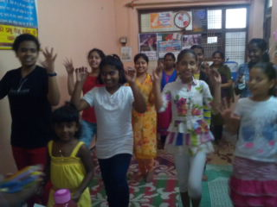
Children from every religion and background participated these VBS classes. At the end of the VBS there was a get together for the parents of these children where we shared the word of God with them.
Children were excited to perform what they learned, before their parents. Gifts were distributed for all the partcipants. Bibles in the local languages were given to all the parents.
During our visit to their house, parents told us, what they have learned from us are helping their children to lead a discipled life and lot of changes have taken place in their attitude. We thank God for the opportunity He gave us to train these children to be better citizen for our nation.
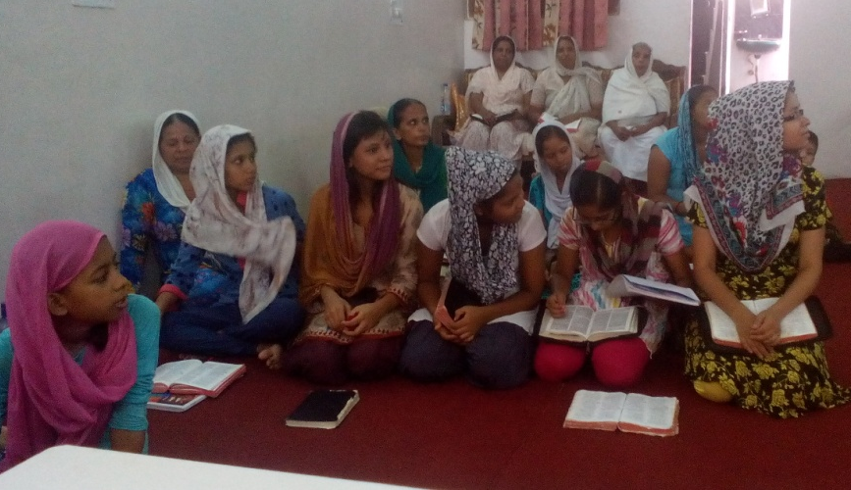
New Prayer fellowship was started in the beginning of the year 2016 in Aya Nagar, New Delhi. All of them are saved from non-Christian families.
Everyone in this fellowship are experiencing the power of God in their personal life in different ways. They are growing in the Lord and sharing the Gospel to their families and friends in their working place. Their living testimonies are drawing people to believe in Christ. Please remember this fellowiship in your prayers.
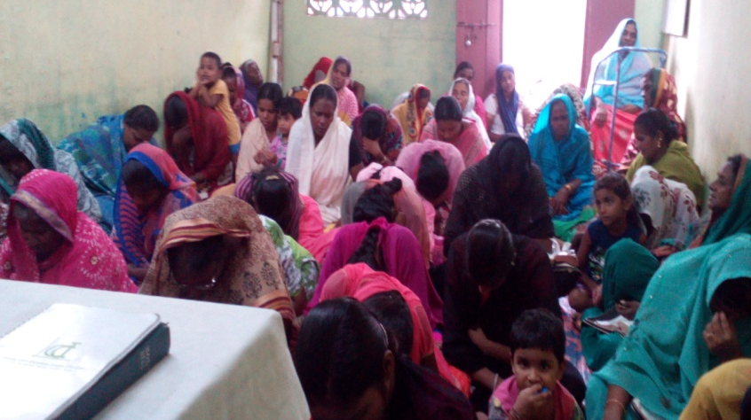
God also has called to teach and train people for the Gospel work and also strengthen the body of Christ, by visiting Churches and training the Church leaders.
I was able to visit some Churches in variious places in India. One of the churches that I visited is in Tenali, Andhra Pradesh.
Tenali is a remote village with full of Hindu temples, In Andra Pradesh. There are few churches in this area. Believers have many miraculous stories about how they came to Christ, such as healing from sickness, deliverance, miraculous things and restoration of relationship etc.
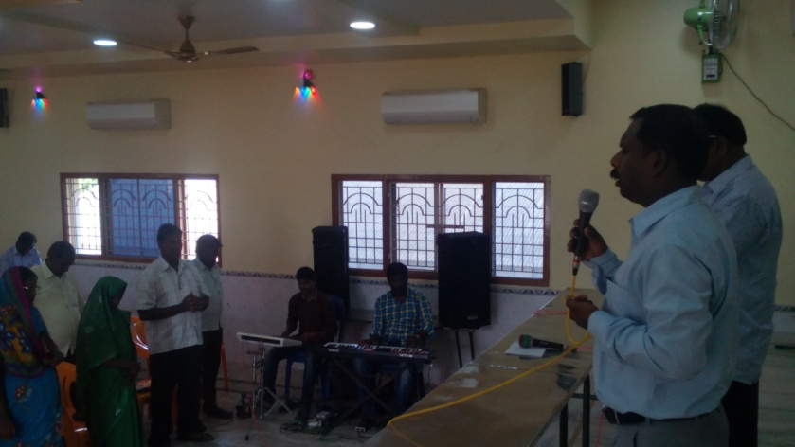
Training the leaders for the Gospel work was organized in New Delhi, Andhra Pradesh and in Uttar Pradesh. 400 Leaders, laymen, young people and Bible College studetns attended these training camps.
After these training programs, all the participants came forward to us with a new decision to work for the Lord and reach more lost souls. Many young people commited their life to go for the Lord wherever He send them to sharing the Gospel.
We are getting good reports from many of them, saying that God is working mightily among them and many new people are coming to Christ everyday. Few prayer cells are started already through these young people in different parts of India.
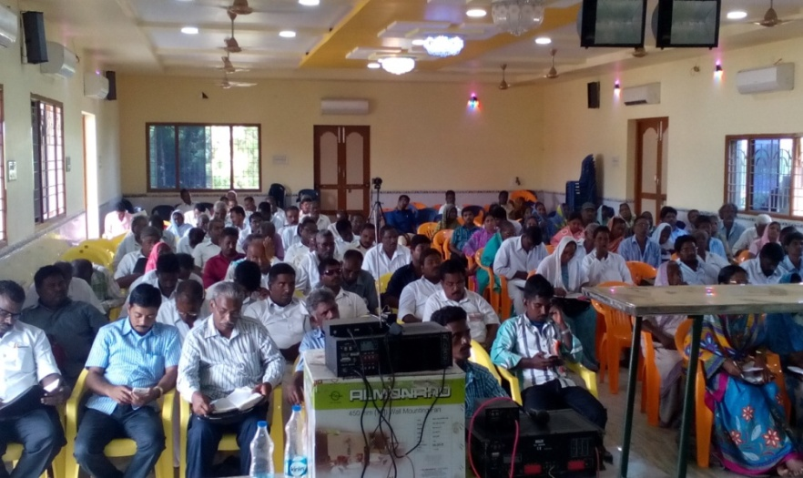
In India, there are thousands of Gospel workers laboring in remote villages and slums. Many of them are not privileged to get such training and encouraging classes. Once they have completed their Bible schools or colleges they go to the mission fields and they are isoloated there for ever.
We are praying for God to help us to organise such training for these Gospel workers and church elders. It may be even for one day, it will refresh them spiritually to do more with a tremendous courage. Please pray.
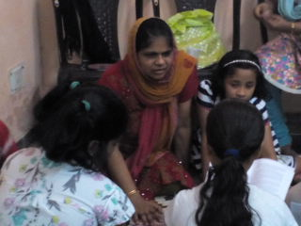
My wife, Ajitha is a great help in my ministry. She is actively working among the women and children in our area and in the church.
She takes the Gospel books, New Testament Bibles etc. to our neighbouring houses and area and share about the love of Christ to women and pray for them.
She has started a free educational class for the underprivileged children in our home. Through this she is getting more chances to go and visit many families. 10 children are coming for this class.
She is praying for God to open doors for her to help these children for their educational needs, such as books, school bags, tiffin box, shoes etc. Please pray for God’s provision.
God has blessed us with two children. Our daughter Sancia(12 years) studying in 6th standard and the son, Sharon(8 years) is studying in 3rd standard. They are growing in the Lord. Please pray for them and their studies.
As the year 2017 is started with a new hope, we want to reach more people in this year than previous year and want to visit many new places. Your prayers for us are highly appreciated.
We are praying for a motor bike, an overhead projector and some Musical instruments for our ministry and church needs.
You are in our prayers and hearts.

Pastor Santhosh Chellappan

